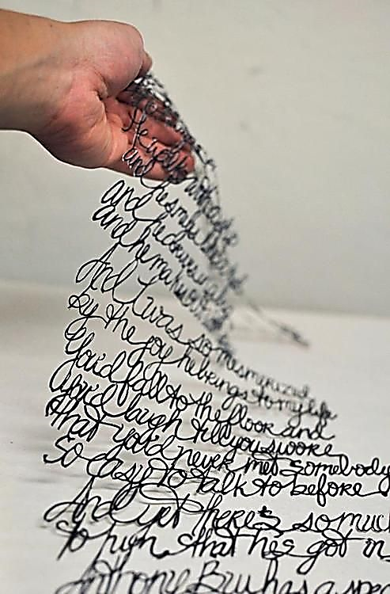
Poëzieparcours
Bundeltje vol plezier!
Dit bundeltje is van:
______________________________________

Gedicht 1

Maakt jouw school gebruik van wegwijzers om de juiste klas te vinden?
Als jij de baas was, wat zou jij dan op de wegwijzers noteren? Alles mag!
Maak je eigen wegwijzer of vul die hieronder in.

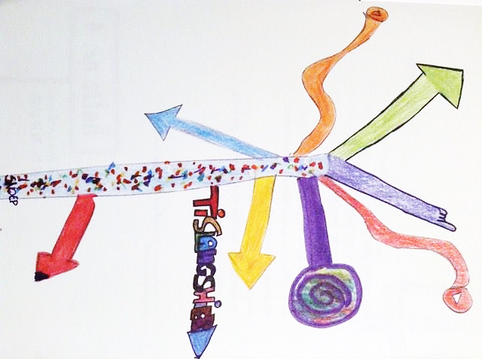

Wat is jouw lievelingsplekje op school? __________________

Gedicht 2
Wat betekent onzichtbaar voor jou?
Heeft dat een bepaalde kleur?
Of is het een bepaalde vorm?
Teken, kleur of schrijf het in woorden!

Gedicht 3

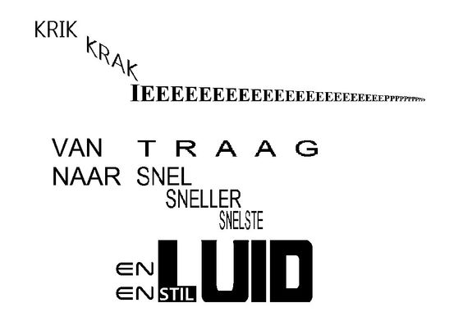
Nog een voorbeeld!

Bij visuele poëzie worden woorden en beelden door elkaar gebruikt.
De beelden versterken de bedoeling van de woorden.
Kan jij dit ook?!
Kijk om je heen, laat je inspireren en maak een visueel gedicht!

Gedicht 4

Noteer hier je opmerkingen, krabbels, …

Jow jow jow!
Kan jij dit versje met je groep rappen?
Of prikkelt dit gedicht om een eigen tekst te maken?
Straks wil ik het heel graag horen!

Gedicht 5
Een beetje slakkenslijm hier, nog wat nagelteentjes daar …
De heks is goed bezig met haar lekkere heksensoep!
Wat zit er in jouw soep als jij een tovenaars of heks zou zijn?
Welke naam zou je soep krijgen?
Noteer of teken je verrukkelijk receptje in de wolk.

Naam zelfgemaakte soep: ____________________________

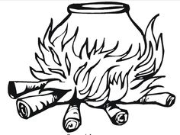

Gedicht 6
Wat wil jij heel graag worden? Waarom?
Wat zou jij dan zeker willen leren?
Naar wat voor een soort school zou jij gaan?
Deel je gedachten met elkaar en schrijf het op!

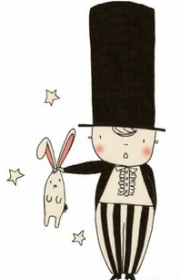

Later wil ik ___________________________________________ worden!

_____________________________________________________________________
_____________________________________________________________________
_____________________________________________________________________
_____________________________________________________________________
Zo ga ik er later uitzien:

Gedicht 7

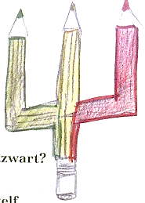
Kan jij zelf nieuwe kleuren verzinnen?
Wat dacht je van boterbloemgeel of nachtzwart of …?
Hieronder is plaats voor al je mooiste kleurennamen!
Hoe zouden je kleuren eruitzien?

Gedicht 8

Bekijk de heerlijke snoepjes in het uitstalraam.
Laat nu je fantasie werken en teken je zelfbedachte snoepjes.
Verzin er ook bij waar de snoepjes goed voor zijn, zoals bijvoorbeeld van drop word je top.

Van ______________________________ word je ______________________
Van ______________________________ word je ______________________
Van ______________________________ word je ______________________
Van ______________________________ word je ______________________
Van ______________________________ word je ______________________
Van ______________________________ word je ______________________
